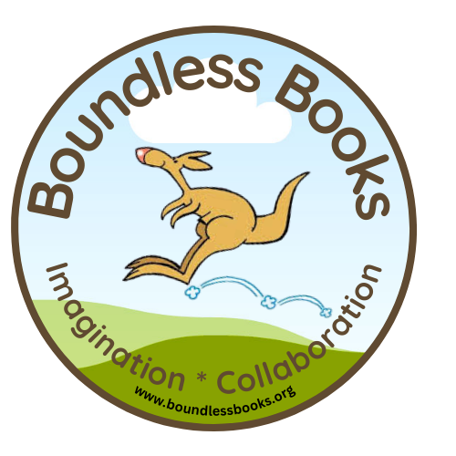

Boundless Books Testimonials

Dr. Beth Kramer
Principal
Walberta Park Elementary
The boundless program gave our students a chance to work together, come up with creative ideas, and collectively invent a story that they were all proud of. Every student had a voice and also a picture in the published, final copy. A unique and fun experience for all learners.

Maura White
AIS Teacher
Van Duyn Elementary
Our collaboration with Boundless Books was a unique experience for the students of Van Duyn
Elementary. The project, led by Mark Eischen, gave them the opportunity to work with students from Walberta Park Primary School to share ideas, laughs, and their imaginations. Mark encouraged and supported them with his artistic energy as they transformed into young authors and illustrators. It was inspiring to see the students’ creativity mesh together and culminate with a book of their very own.

Erica Sinicropi
Vice Principal
Port Byron Elementary
Working with Mark Eischen was a great experience all around! The Boundless Books project lends itself to obvious connections to the curriculum as well as providing students with a real-life opportunity to gain an understanding and appreciation for the processes of writing, illustrating and publishing a book. The unexpected benefit of this project was that it catapulted students ability and desire to be creative, collaborate and problem solve. Students self-esteem and excitement for learning grew with each session that they had with Mark. Lastly, our entire school is beyond proud of the book that our First graders created!

Tomoko Stultz
2nd Grade Teacher
LeMoyne Elementary
I have heard that everyone has had a wish of writing a book at some point in her or his life. But how many people can actually make this dream come true? Our 1st and 2nd grade students who attended summer school at Lemoyne this year did. Thanks to Mr. Mark Eischen, the students made a book and now it is selling on Amazon!
While they were discussing what the book should be about, almost all students were actively engaged and shared their ideas; what animal the main character should be, the animal's name and gender, and all about the animal. Not everyone is good at drawing, but they all enjoyed drawing a picture they were assigned to and did their best. When I told them in the classroom that Mr. Mark was coming to bring you a book, the students screamed and couldn't wait to see him and to receive the book they made. When they got the book, there was silence for a while. No one could talk; they were captivated by the book they had just made. I think they couldn't believe that they actually made a book! The girl whose picture was chosen to be the front cover proudly hand-delivered the book to our librarian.

10 or 20 years, even 50 years from now on, the students will be still proud of what they made and treasure this book as long as they live.

Mr. Mark Eischen, thank you very much for giving the students one of a kind experience this summer. Not only the students but also Ms. Clare Kiskadden and I really enjoyed this special experience.

Amy Bellamy
First Grade Teacher
Port Byron
The Boundless Books project was the best memory for my first grade class. They loved working with Mark Eischen. Each week, the class looked forward to creating the story with him. Mark was so warm and caring to our students. I saw my class blossom in writing in the classroom. They were making illustrations and creating books for him each week. Mark took the time to look at each students work. All around the experience was truly amazing for our students. The day they received the book was so exciting. They all opened it up and read it aloud in the classroom. Port Byron is so proud of our book!

Carrie Weaver
1st Grade Teacher
Frazer School
Mark Eischen visited my summer school classroom and worked with second graders on writing and illustrating a book this summer session. His enthusiasm and energy was infectious and he kept the students engaged from the beginning of the process until he presented the students with the final project.
Mark took students who were hesitant to share their thoughts and ideas and showed them how to brainstorm, collaborate, and compromise in order to work together to create a story about a Husky that didn’t like the cold.
Each child was given a book that they had created to take home and share with their families and friends. The excitement in the classroom on that day was amazing! Mark had taken kids with low self- esteem and turned them into confident published authors and illustrators! Mark motivated and challenged students who thought they weren’t good at writing or drawing and showed them the power of teamwork and believing in themselves.
This was an awesome experience and I hope to have Mark Eischen back in my classroom to motivate and challenge my students into writing another exciting story.

Stephanie Merritt
1st Grade Teacher
Walberta Park Elementary
Mark Eischen and the Boundless Books Program were an exciting part of our curriculum this past year. His visits spurred authentic interest in books, reading, writing and illustrating. Students were eager to spin ideas and Mr. Eischen’s enthusiasm is contagious. Our final product Wumpy is a treasure filled with positive memories of the process of publishing a book. It was truly an experience these kids will not forget!

Lynn Powers
2nd Grade Teacher
Port Byron Elementary
The experience gave the students more confidence and a greater understanding of becoming an author and illustrator. After seeing the story in print the students were so excited and proud of themselves.Thank you for the experience!

